Lung Capacity Lab
16

MC

Human lung capacity can be measured in several ways. One way, is by using a piece of laboratory equipment called a lung bag. Several different lung volume measurements can be made. The largest possible amount of air that can be exhaled after drawing a deep breath is the vital capacity. The amount of air that remains in the lungs after exhaling normally but which can be expelled is the expiratory reserve. The amount of air taken in or expelled during normal breathing is called the tidal volume. A certain amount of air in the lungs cannot be expelled. This is the residual volume.

Purpose: To determine your lung capacity.

Procedure:
First get familiar with the lung bag. Notice that it has to be completely emptied of air prior to filling. The mouthpiece must be secured with a rubber band in a manner not to block the flow of air. Once you’ve measured a few test breaths move on to taking the data.

Part A: Vital Capacity

1. Take as deep a breath as possible. Then exhale all the air you can into the lung volume bag

2. Measure and record your vital capacity in cubic centimetres in column A of the Data Table.

3. Do three more trials and calculate your average.

Part B: Expiratory Reserve

1. Exhale normally.

2. Without inhaling as you normally would, put the lung bag to your mouth and exhale all the air still left in your lungs.

3. Measure and record your expiratory reserve in cubic centimetres in column B of the Data Table.

4. Do three more trials and calculate your average.

Part C: Tidal Volume

1. Take in a normal breath. Exhale into the lung bag only as much air as you would normally exhale. DO NOT force your breathing.

2. Record your tidal volume in cubic centimetres in column C of the Data Table.

3. Do three more trials and calculate your average tidal volume.
(6 marks)
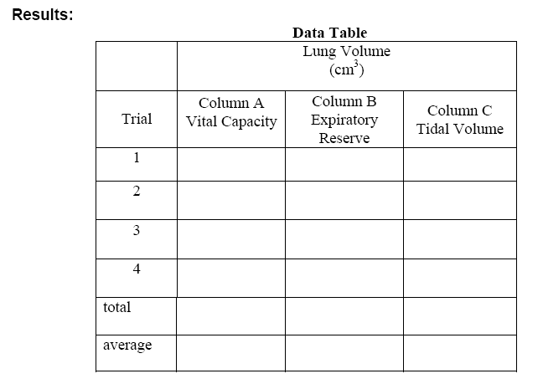

Analysis: Compare results to normal (average) lung volumes for males and females.
“Average” Lung Volumes Measured with a Spirometer

Male |  | Female
Vital Capacity | 5000 cm3 |  | 4000 cm3
Expiratory Reserve | 1200 cm3 |  | 1000 cm3
Tidal Volume | 525 cm3 |  | 475 cm3

Conclusion: Answer the following in complete sentences on this sheet (16 marks)

1. What was the purpose of this investigation? (2 marks)

2. Compare/contrast your results with the average values. Why do you think there are differences? (2 marks)

3. What are three things that could be affecting your lung capacities? (3 marks)

4. Some organisms don’t have lungs. What structure do they use to exchange gases? (2 marks)

5. What is cellular respiration? How is it connected to this organ system? (2 marks)

6. Define respiratory surface. (1 mark)

7. At the respiratory surface, what process actually causes O₂ to go into the blood and CO₂ to go out of the blood? (2 marks)

8. What is the benefit of having so many tiny alveoli rather than one big air sac? (2 marks)

