How Can You Locate The Epicenter of an Earthquake?
Three Types of Waves
An earthquake epicenter can be located from records made of earthquake waves on devices called seismographs. A typical seismogram of an earthquake has three prominent wave patterns, seen in figure 1. The first waves to arrive from are the P-waves (also called "primary" or "push-pull"). They are followed by the S-waves (also called "secondary," "shear," or "shake"). Finally, the L-waves ("long" or Surface wave) arrive.
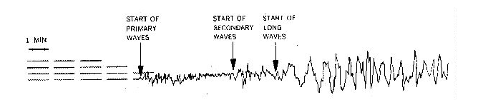
Figure 1: A Seismogram

The central assumption for using this methodology for calculating the distance to the earthquake epicenter is that the speed of the earthquake waves does not change with distance. However, in reality, this does not hold true over long distances, especially if the earthquake waves penetrate the denser layers of the earth's interior, which causes earthquake waves to speed up in general.
Seismologists determine the distance to an earthquake’s epicenter by:
- Measuring the separation on any seismogram.
- Identifying that same separation time on the travel-time graph.
Measuring the Separation on a Seismogram
At least 3 earthquake-recording stations are required to find the location of the earthquake epicenter. A single recording station can only calculate distance, but not direction; to cover all possibilities; a complete circle is drawn around that station. If only two earthquake-recording stations are used, the circles will overlap at two points. When data from a third seismic station is added, the rings will overlap only at one point—the epicenter.
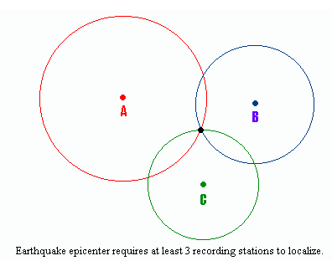
Figure 2: Seismogtram Readings

Identifying Separations Times On Travel-Time Graph
Seismologists read the travel time of either (s or p) wave to the epicenter from that station using graphs similar to the one shown in Figure 3. For example, consider a seismogram that registered the arrival of P-waves at exactly 10:00 a.m. If the P-waves traveled 4500 km, and took 8 min according to the appropriate travel-time curve, then it can be determined that the earthquake occurred at the focus at 9:52 a.m.
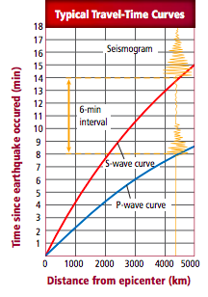
Figure 3: Travel time curve. Including seismo graphic data.
Locating the Epicenter of an Earthquake
Objective: To identify the location of an earthquake epicenter using a travel time graph and three seismograph tracings.

Procedure:
1. Study the three seismograph tracings. Notice the time scale below each tracing. Each mark on the time scale represents one minute.

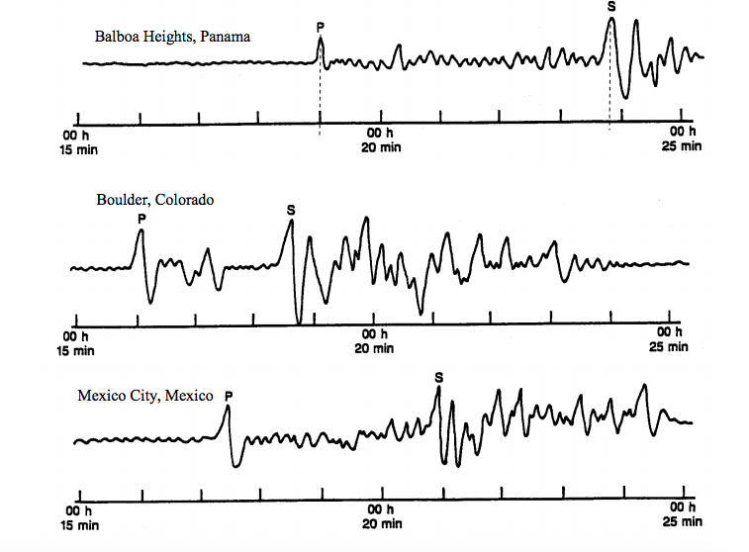

2. Start with the first tracing, labeled Balboa Heights. Locate the P, which indicates the arrival time of the P wave at the seismic station, and the S, which indicates the arrival time of the S wave. Draw a line straight down from the peak of the P wave to the time scale and another line from the peak of the S wave to the time scale. Record the arrival times for each city on the data table.

Data Table
City | P-wave Arrival Time | S-wave Arrival Time | Difference Between P-wave and S-wave | Distance to Epicenter
Balboa Heights
Boulder
Mexico City

3. Determine the difference between the arrival times of the P and S waves.

On the “Earthquake P-wave and S-wave Travel Time” graph below, Lay the edge of a piece of paper along the vertical axis of the graph. Place a mark on the edge of the paper at 0 on the vertical axis and another mark corresponding to 4 min 50 s. Keeping the edge of the paper straight up and down, slide the paper across the graph to the place where the P and S curves are the same distance apart as the two points you marked. The point where the paper meets the distance scale at the bottom of the graph indicates the distance to the epicenter. *See the below example for Balboa Heights.*

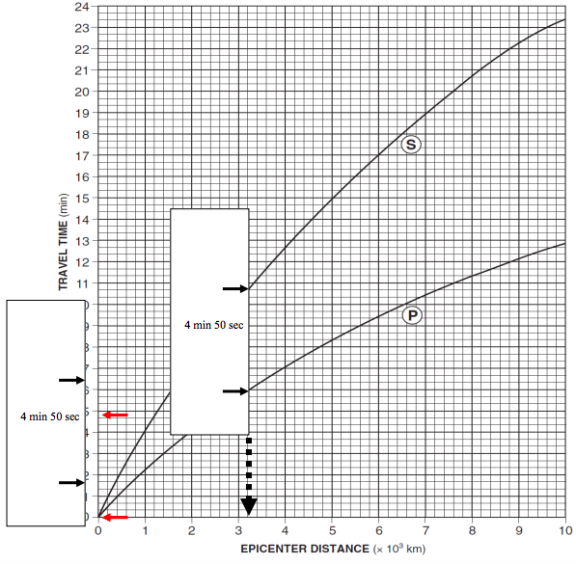

4. Using the Earthquake P-wave and S-wave Travel Time graph below, determine the distance to the epicenter from each city. Be sure to enter this information on the data table.

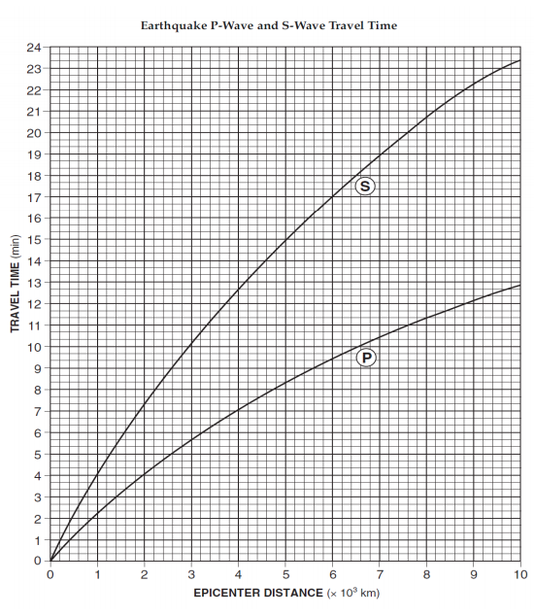

5. Now locate Balboa Heights (BH) on the map. Next measure a radius, the length of the distance to the epicentre, on the map scale. Draw a circle with that radius around Balboa Heights. Repeat procedure steps for Boulder and Mexico City.

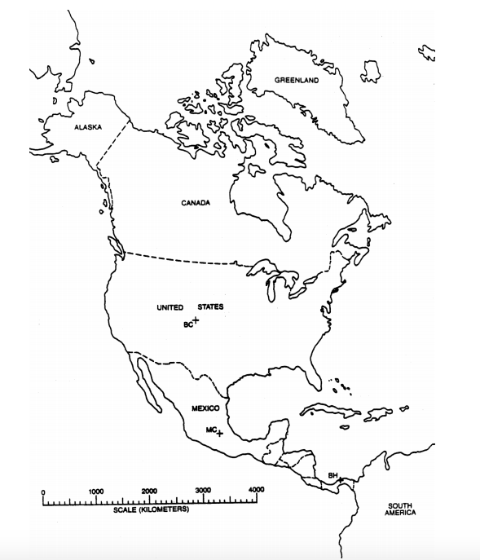

Analysis and Conclusions

- After drawing the circle for Mexico City, you now have three circles on your map. Relative to the three circles, where is the earthquakes epicentre? (Highlight location on map)

- As the distance to the epicenter increases, how does the amount of time between the S wave and the P wave change? Refer to the graph.

- Give the location and year of the major earthquake from the past that occurred in the same area as the epicenter you have just located.

- Would it be possible for an earthquake at this same location to be felt where you live? Why or why not?

