SES 4U- Earth’s Interior Structure

- Label the Internal structure of the Earth:

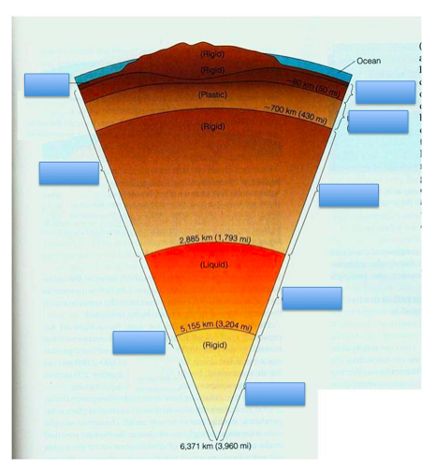

- Complete the Chart Below:

 | Composition | State | Depth from Surface  (our text numbers)  (km) | Temperature  (ºC)

Inner Core

Outer Core

Mantle
(largest layer)
Asthenosphere- (upper portion of mantle which is thin slush-like layer)

Lithosphere – (includes the crust and the uppermost-top part of mantle)

Crust

