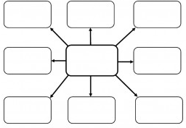
PICK YOUR VOLCANO OUT OF THE BAG!!!

In the center box of your mind-map include the volcano name and a sketch of the volcano.

Within the boxes of your volcano mind-map include:
- The location of your volcano. What tectonic plates is it near?
- Volcano anatomy. Include measurements (ex. height , width..)
- Type of Volcano. Evidence to support this.
- Composition of Magma.
- Historical events/eruptions.
- Volcanic Hazard
- Are there any precautions taken for potential eruptions in the surrounding area?
- Fun Volcano Fact!

Volcanos:

Mt. Redoubt Lava Butte Galeras

Pinatubo Yellowstone

Sunset Crater Mount Nyiragongo

Vesuvius Hualalai

Popocatepet Paricutín

Arenal Volcano Poás Volcano Mount Rainier

Kilauea Mauna Loa Mount St. Helens

Kohala Volcano Mount Fuji Mount Shasta

