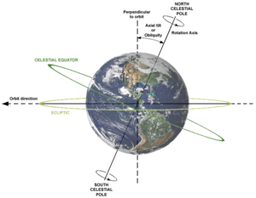
Stellar Terminology

Celestial Equator
- A circle around the earth following the same plane as the equator
- As the Earth is tilted, the celestial plane is 23.4⁰

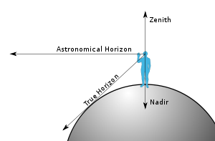
Zenith
- The direction pointing directly ABOVE a certain position on the Earth
- The opposite direction is called the NADIR

Ecliptic

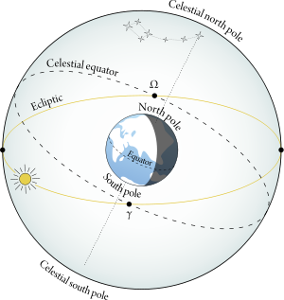
- The plane of the Earth’s orbit around the Sun
- Named also after eclipses in which the moon (usually full) moves into that orbit

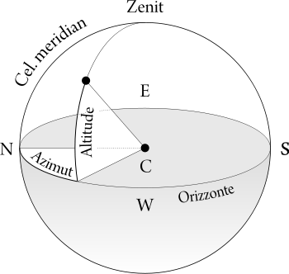
Azimuth
- A measurement of a position of a star in the sky, in degrees
- Uses the horizon as a reference plane, and is usually referenced from the north

Right Ascension (RA)
- The term referring to one of two coordinates of a point on a celestial sphere
- Similar to Earth’s longitude coordinate system

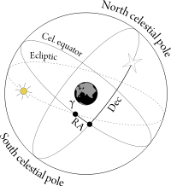

Declination
- One of two coordinates used along with RA
- Celestial equator is 0⁰
- Celestial north pole is + 90⁰
- Celestial south pole is -90⁰

