Vascular Plants (vs. Non-Vascular)
Non-vascular Plants
- Cannot transport foot or water between plant parts
- Transport of fluid is through simple absorption or osmosis
- Must live in moist environments; need water for reproduction
- Typically very short and low to the ground for constant water supply

Vascular Plants
- Contain a vascular system allowing for transportation of nutrients / water throughout the plant, similar to blood vessels
- Typically grow taller than non-vascular plants (complete with stems, larger leaves) because water and nutrients can be conducted upwards

Vascular Tissues in Plants
- Instead of arteries, veins and capillaries, plants have two types of vascular tissue in stems:
  - Xylem transports water and dissolved minerals
  - Phloem transports sugars and proteins (food!) through stem
- Vascular Cambium layers of cells between xylem and phloem that are able to divide
- Vascular cambium forms a continuous cylindrical layer inside the stem that can reproduce
- Vascular cambium cells divide to form new xylem cells towards the inside of the stem and new phloem toward the outside of the stem
- Form tree rings

Structure of a Flower (in Angiosperms)
- Pistil: female reproductive structure
  - Stigma: sticky tip; traps pollen
  - Style: slender tube; transports pollen from stigma to ovary
  - Ovary: contains ovules; ovary develops into fruit
  - Ovule: contains egg cell which develops into a seed when fertilized
- Stamen: male reproductive structure
  - Filament: thin stalk; supports anther
  - Anther: knob-like structure; produces pollen
  - Pollen: contains microscopic cells that become sperm cells
- Sepals: encloses & protects flower before it blooms
- Petals: usually colorful & scented; attracts pollinators

Cross-Pollination
- How does pollination happen?
  - Pollen from an anther is caught by the stigma, travels through style to the ovules in the ovary.
- What is the result of pollination?
  - A Fruit: An ovary containing seeds.

Breaking it Down Further

Monocots vs. Dicots
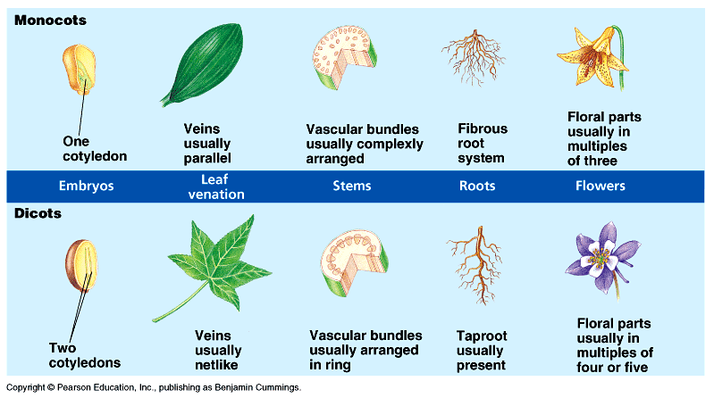
Monocot | Dicot
- Vascular bundles are not arranged in a circle, but are usually scattered throughout the ground tissue. There is no clearly defined pith as there is in many dicot species.  - The xylem orientated towards the middle of the stem and the phloem towards the outside. | - Vascular bundles are arranged in a circle in the middle of the stem surrounding a central pith. To the outside of the vascular bundles is the cortex which is covered by a single layer of epidermis cells.  - The xylem orientated towards the middle of the stem and the phloem towards the outside.
Plant Hormones
- Plant cells can produce hormones: which are chemical messengers that travel throughout the plant causing other cells called target cells to respond.
- In plants, hormones control:
- Plant growth & development
  - When trees to drop their leaves.
  - When to start new growth.
  - When to cause fruit to ripen.
  - When to cause flowers to bloom.
  - When to cause seeds to sprout.
- Plant responses to environment
Tropisms
Tropism: the way a plant grows in response to stimuli in the environment.
  - Phototropism: growth response to light
Positive: Plants bend towards light Negative: Plants bend away from light
  - Thigmotropism: growth response to touch
  - Ex. vines grow up around trees, ticklish plant closes when leaves are touched

Key Words: Vascular Plants (vs. Non-vascular)

- Non-vascular tissue
- Vascular tissue
- Xylem
- Phloem
- Vascular cambium
- Monocot
- Dicot
- Pistil
- Stigma
- Style
- Ovary
- Ovule
- Stamen
- Filament
- Anther
- Pollen
- Sepal
- Petal
- Pollination
- Cotyledon
- Hormones
- Target cells
- Tropism
- Phototropism (positive and negative)
- Thigmotropism

