Plate Tectonics

Continental Drift becomes Plate Tectonics:
- idea that Earth’s surface might be moving is not new
- in early 1500’s, explorers noted the remarkable fit of world’s continents
is like a puzzle
- first formal theory proposed by German scientist Alfred Wegener in 1912 called “continental drift” which states that the continents had drifted or moved from one location to another over time
- by the 1950’s and 1960’s scientists had further developed this theory and called it “plate tectonics” – the Earth’s lithosphere is divided into plates (made up of both continents and ocean basins) that move on top of the asthenosphere
- the plates are currently moving towards each other, moving away from each other, or sliding past each other

Scientific historical evidence for theory:
*ages and similarities of rocks amongst continents
*similar fossil records amongst continents
*glacier tracks in rocks of southern continents indicates that they were
once in colder northern climates
*zones of earthquake and volcano activity are all along where plates meet
*supercontinent Pangaea of approximately 250 million yrs ago broke apart
into two landmasses Gondwana and Laurasia and eventually continued to
break apart to current location of continents

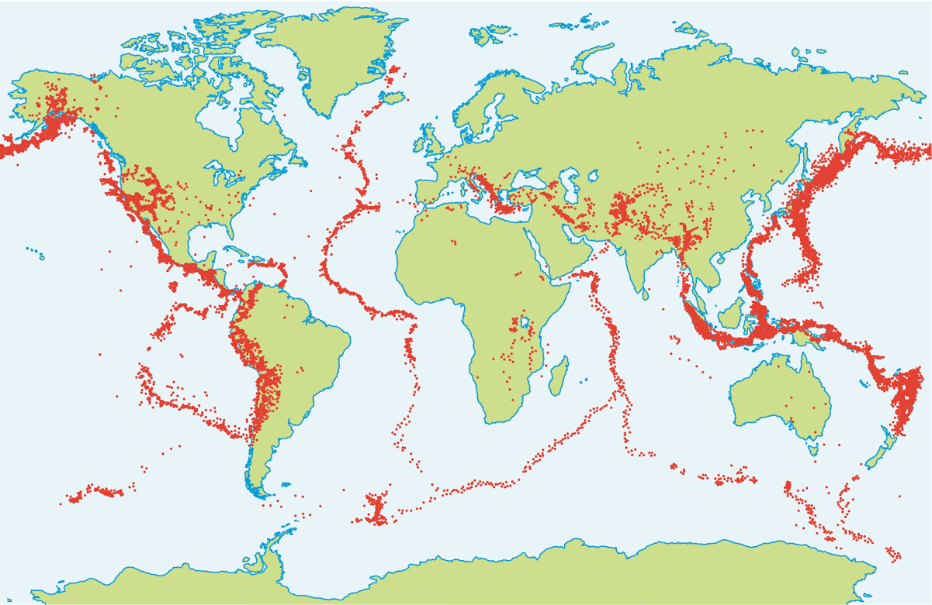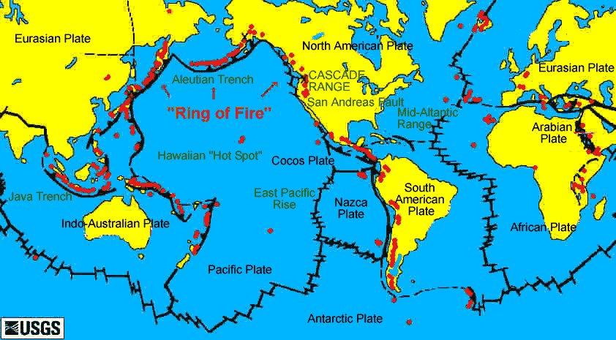
Earth’s Tectonic Plates:
- there are 12 major plates and several other smaller ones

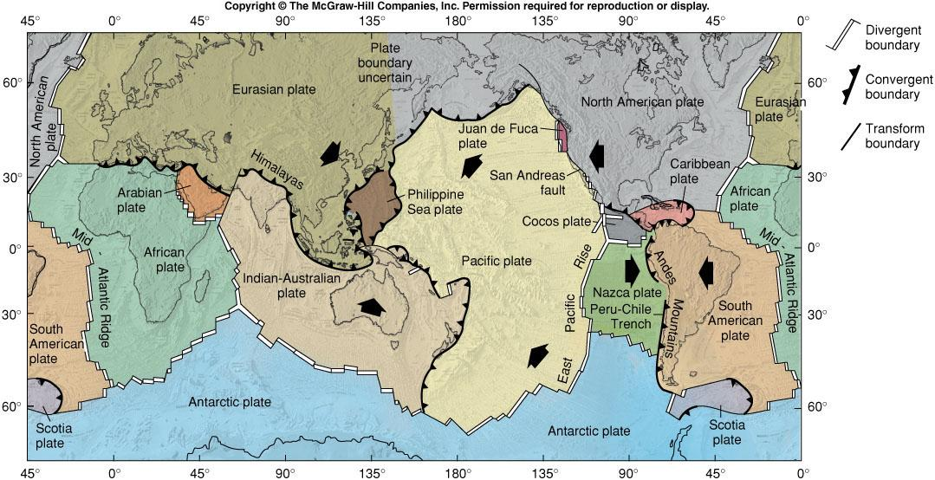

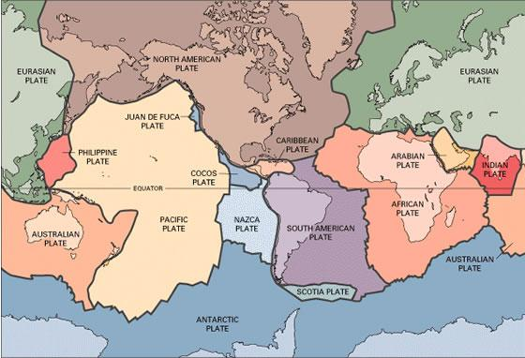

Types of Plate Boundaries Determined by Movement

Divergent Boundaries:
- boundary between 2 lithospheric plates that are moving apart

Convergent Boundaries:
- boundary between 2 lithospheric plates that are moving towards each other

- convergent subduction boundaries: when an oceanic plate plunges beneath another plate – it can either be two ocean plates where one goes under the other, or an ocean plate under a continental plate

- convergent collision boundaries: when two continental plates collide and are welded together to become one larger plate

Transform Boundaries:
- boundary between 2 plates that are sliding past each other

Summary Table:
Boundary Type | Process Involved | Characteristic Features | Current Examples
Divergent | sea-floor spreading | *mid-ocean ridges  *rift valleys  *earthquake activity at fracture zones along mid-ocean ridge  *volcanic activity | *Mid-Atlantic Ridge  *East Pacific Ridge
Convergent Subduction | subduction  ocean-ocean | *deep-sea trenches  *volcanic island arcs  *earthquake activity | *Indonesian Islands
 | subduction  ocean-continent | *deep-sea trench bordering continent  *volcanoes along coast of continent  *earthquake activity | *western coast of  South America (Chile)
Convergent Collision | collision  continent-continent | *high continental mountain chains  *earthquake activity | *Himalayas
Transform | plates sliding past each other | *earthquake activity | *San Andreas Fault (California)

Causes of Plate Movement:
- three hypotheses have been developed and scientists now believe all three play an equal role in moving the plates

1) Mantle Convection:
- heat from the inner and outer core is transferred up through the mantle which them moves the plates above it
- this happens when magma that is hotter and less dense rises upwards on one side of a convection cell and then as the convection current cools it moves away it a circular motion which then drags the lithospheric plates above it
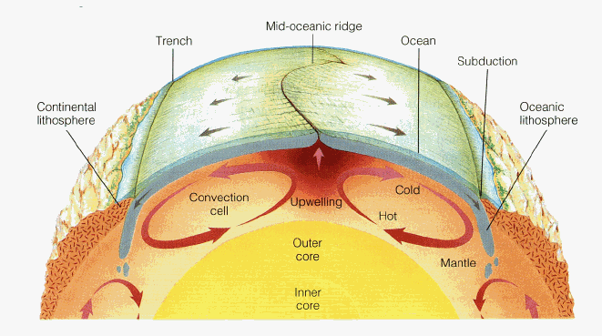

2) Ridge Push and 3) Slab Pull:
- magma that rises upwards at mid-oceanic ridge is extremely hot and as it accumulates it builds up and pushes the ridge apart
- then as magma cools it slopes downwards pulling apart the lithospheric plates at the subduction boundary – this force is much stronger than the magma push
- ridge push and slab pull processes continually repeat as newer hotter magma rises and then cools

