Isotopes have many uses in science communities and in industrial processes, yet most people are unaware of any of them. Most elements have multiple isotopes, but some are more abundant and more useful than others. Your assignment is to research and present information on an isotope that has some value to the scientific community, industrial processes or in some other way.
Each student will have a UNIQUE isotope they will be researching, so make sure to register your isotope with your teacher.

My Isotope:
You will create an infographic. This assignment is not meant to involve intensive research; it is meant to familiarize and introduce yourself and your classmates to isotopes that they probably never knew existed.
Questions to consider
(Recommended guiding questions: answer some of them, none of them or all of them. They are simply meant to guide you in the right direction)
- What is the isotope used for? Medical? Industrial?
- What is the abundance worldwide? Where is it found?
- Where is it globally deposited? Why? (Question mostly for mined isotopes)
- Is it hazardous to humans?
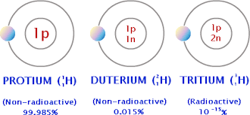
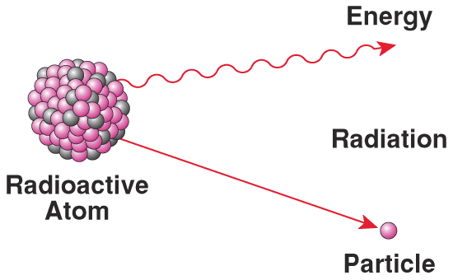
- What type of radioactive decay does it go through?

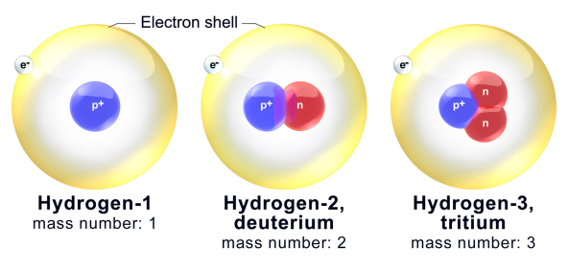
Category | 0 1 2 3 4 | 5 6 | 7 8 | 9 10
Content | • topic is described in poor detail  • did not use scientific knowledge to describe the chemistry of the compound | • topic is described in little detail  • used little scientific knowledge to describe the chemistry of the compound | • topic is described in detail  • used scientific knowledge to describe the chemistry of the topic | • topic is described in significant detail  • used sound scientific knowledge to describe the chemistry of the topic
Communication | • communicates information and ideas with limited clarity and precision  • uses scientific terminology with limited accuracy and effectiveness  • many spelling and grammatical errors | • communicates information and ideas with moderate clarity and precision  • uses scientific terminology and symbols with some accuracy and effectiveness  • some spelling and grammatical errors | • clear and logical flow of ideas in written report  • usually uses scientific terminology and symbols with a degree of accuracy and precision  • few spelling and grammatical errors | • communicates information and ideas with a high degree of clarity, indicating a thorough understanding of the concepts  • uses scientific terminology and symbols with a high degree of accuracy and precision  • very few spelling or grammatical errors
Making Connections to Society and/or the Environment | • demonstrates limited understanding of the connections of this topic to our everyday lives  • assessed societal and/or environmental impacts with limited effectiveness | • demonstrates some understanding of the connections of this topic to our everyday lives  • assessed societal and/or environmental impacts with moderate effectiveness | • demonstrates a considerable understanding of the connections of this topic to our everyday lives  • assessed societal and/or environmental impacts with considerable effectiveness | • demonstrates a thorough understanding of the connections of this topic to our everyday lives  • assessed societal and/or environmental impacts with a high degree of effectiveness
Research, Resources and References | • poorly researched | • fairly well researched  • more than one resource referred to  • references missing | • good research into the event.  • a few resources referred to  • references present and cited | • excellent and thorough research  • varied resources referred to  • references present and properly cited

Total: /40

