Determining the Formula of a Hydrate

What is a Hydrate?

A hydrate is a compound that contains water molecules bound to each formula unit. Hydrates have a chemical formula in the form of A_{x}B_{y}⋅ zH₂O.

An example of a hydrate is cobalt chloride hexahydrate, which has an empirical formula of CoCl₂⋅6H₂O. This empirical formula tells us that each formula unit contains 1 Co atom, 2 Cl atoms, and 6 water molecules.

An anhydrate is the remaining substance once the water is removed. In our CoCl₂⋅6H₂O, the anhydrous form is CoCl₂.
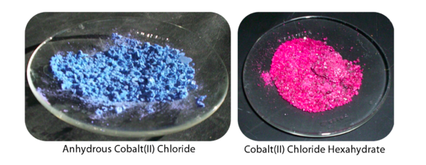

Steps to Determine the Formula of a Hydrate

Step 1: Find the mass of the water that has been removed (or the mass of the anhydrate).
Ie: mass of hydrated compound- mass of anhydrate

Step 2: Calculate the moles of the anhydrous compound

Step 3: Calculate the moles of water

Step 4: Compare the moles of the anhydrous compound to the moles of water.
Ie: find the mole ratio (divide by the smallest number of moles)

Example:
A chemical, lithium sulfate (Li₂SO₄) is hydrated. A sample of the hydrated ionic salt is weighed at 3.25 g. The chemical is then heated, and the water removed. The resulting new mass is 2.80 g. Calculate the empirical formula of this hydrated compound.

Step 1: Find the mass of the water that has been removed.

3.25 g – 2.80 g = 0.45g
0.45g of water has been removed.

Step 2: Calculate the moles of the anhydrous compound.
Li₂SO₄ molar mass:
Molar mass Li= 6.9 g/mol
Molar mass S=32.1 g/mol
Molar mass O= 16.00
Mass Li₂SO₄= (2x6.9) +32.1 + (4x 16) = 109.9 g/mol

Mol Li₂SO₄, n= mass Li₂SO₄
molar mass Li₂SO₄
Mol Li₂SO₄, n= 2.80 g
109.9 g/mol
Mol Li₂SO₄, n= 0.025 mol

Step 3: Calculate moles of water.
H₂O molar mass:
Molar mass H= 1.008 g/mol
Molar mass O= 16.00 g/mol
Molar mass H₂O = (2x1.008) +16= 18.016 g/mol

Mol H₂O, n= mol H₂O
molar mass H₂O
Mol H₂O, n= 0.45 g
18.016 g/mol
Mol H₂O, n= 0.025 mol

Step 4: Compare moles of each

Li₂SO₄: H₂O
0.025: 0.025
0.025 0.025

1:1

Therefore, the formula for this hydrate is Li₂SO₄⋅6H₂O

